# Material Mix-Up

*Play a game to find the best material for the job.*

What to do

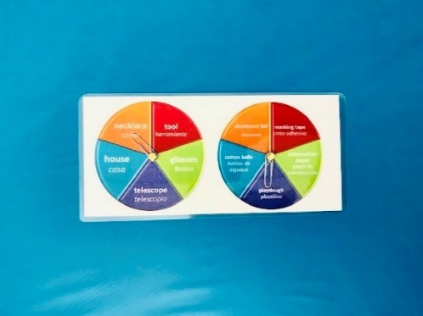­

Did You Know?

1. Make the item that the object spinner landed on.
2. Take only the material indicated by the material spinner.
3. Spin both spinners.

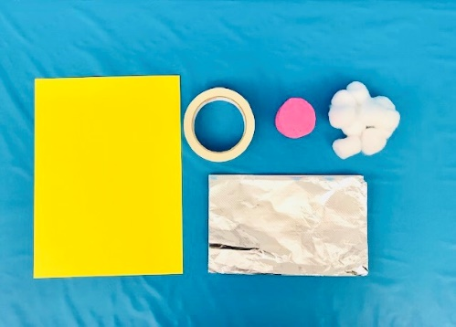



A material’s properties, or characteristics, make it good for some purposes and bad for others. Ever wonder why we don’t wear clothes made out of aluminum foil, or ride bicycles made out of foam? A designer or engineer needs to understand all of the material’s properties in order to select appropriate materials for creating useful items.

# Bridge Builders

*Use different materials to build a bridge.*

What to do

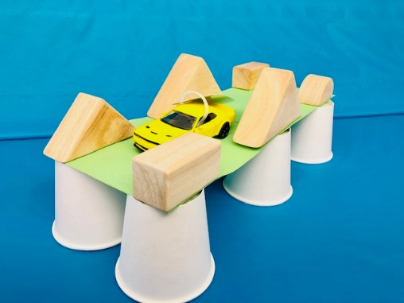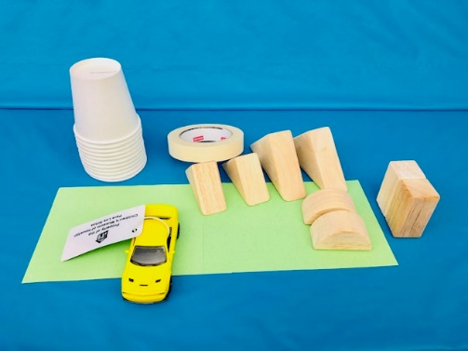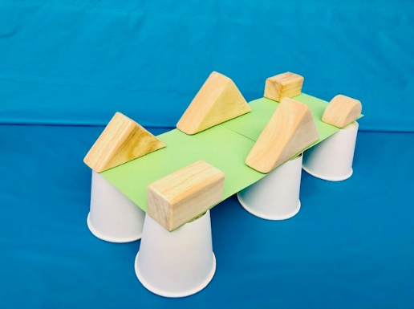­

Did You Know?

Constructive play helps children develop engineering skills. Children who create small-scale structures during play, deal with similar challenges that engineers face to build bridges. There is also evidence that very young children develop better language, math, and problem-solving skills when they engage in regular block play.

1. Use small toys to test how your bridge holds up and if it is necessary make any changes to improve your bridge.
2. Build your bridge with the material you chose.
3. Pick which materials would best to build a bridge. Which would be strong enough to hold a toy car? Or which could you connect to make the longest bridge?

# Hoop Gliders

*Make an object that glides.*

What to do

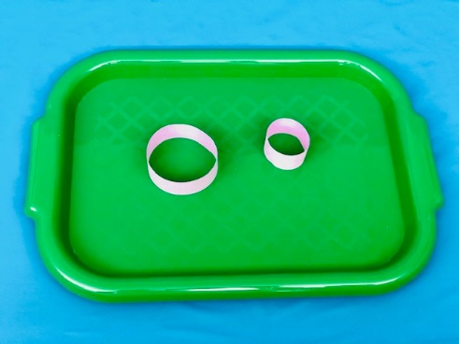 ­

Did You Know?

1. To use it, hold the hoop glider in the middle of the straw with the small hoop in front. Throw it gently like a dart.
2. Make two hoops out of paper strips (one small and the other bigger) by placing the ends of the strips together and taping them.

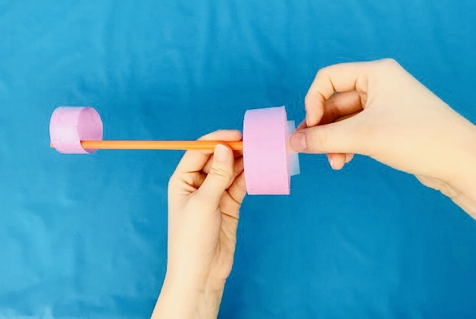

1. Tape both hoops to the ends of the straw.

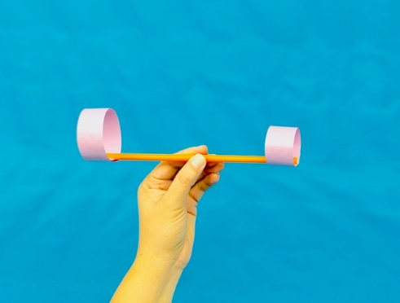

The paper hoops on the Hoop Glider act like wings. The shape of the hoops allows the air flowing around them to create **lift**, a force that pushes the glider up. The force you give by throwing it, called **thrust**, allows the air to flow around the hoops, creating the lift and allowing the glider to soar. For a plane to fly, the lift must be stronger than the **weight**.

# Invent-a-Tool

*Invent a tool for painting in place of a paintbrush.*

What to do

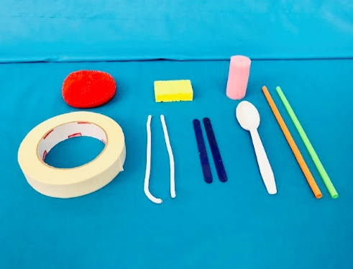 ­

Did You Know?

1. Gather household items like rollers, sponges, straws or anything else that you might want to use to make your tool.

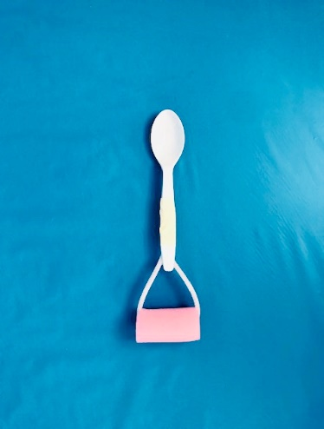

1. Put your items together and create a tool for painting different creative marks.

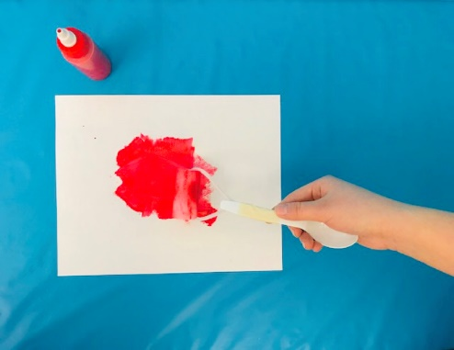

1. Test your tool by using paint and marking it on paper. If it didn’t turn out how you expected, think about how you can change your tool to make the mark you want.

Artists are inventors. They use a variety of tools, traditional and homemade, to transform the creations they imagine into reality. Sometimes an artist wants to create a mark or create an effect that traditional tools just cannot make, so the artist will invent a new tool or use and old tool in a new way, like your child can do it through this activity.

# Lego Dog House

*Build a suitable house for a toy pet.*

What to do

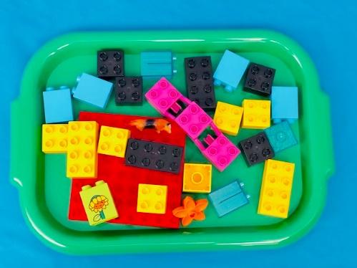 ­

Did You Know?

1. Gather the amount of Legos you think necessary to make a house with the right size for the toy dog.

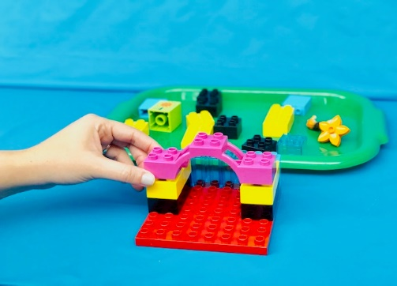

1. Let your imagination fly and build a dog house with the pieces of Legos you chose.

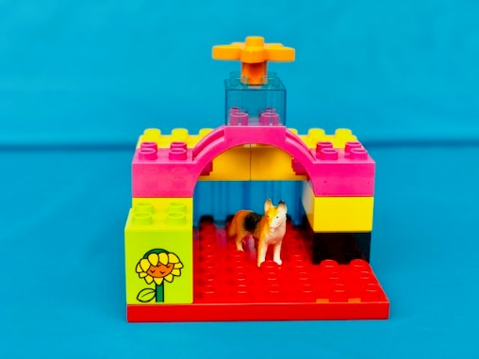

1. Place the dog inside the house to see if it is the right size. If the house is too small or too big for the toy you can try a new construction.

Before developing a construction project, architects and engineers follow two very important steps. First step is to **identify the necessities**, what is necessary to build something, and the second is **imagination**, which leads them to figure out how they will build it. With this activity, your child can explore both creative steps into **the building process**.

# Constructores de puentes

*Utiliza diferentes materiales para construir un puente.*

Qué hacer

1. Elige qué materiales serían los mejores para construir tu puente. ¿Cuáles lo harían suficientemente fuerte para sostener un carro de juguete? O ¿cuáles podrías conectar para hacerlo más largo?

­

1. Usa juguetes pequeños para probar cómo se sostiene tu puente y, si es necesario, realiza cambios para mejorar tu puente.

El juego constructivo ayuda a los niños a desarrollar habilidades de ingeniería. Los niños que crean estructuras a pequeña escala durante el juego, enfrentan desafíos similares a los que enfren- tan los ingenieros al construir puentes. También hay evidencia de que los niños pequeños desarrollan mejores habilidades de lenguaje, matemáticas y de resolución de problemas, cuando participan en juegos de bloques regulares.

1. Construye tu puente con el material que elegiste.

¿Sabías?