CIRCLE Activity Collection: Family
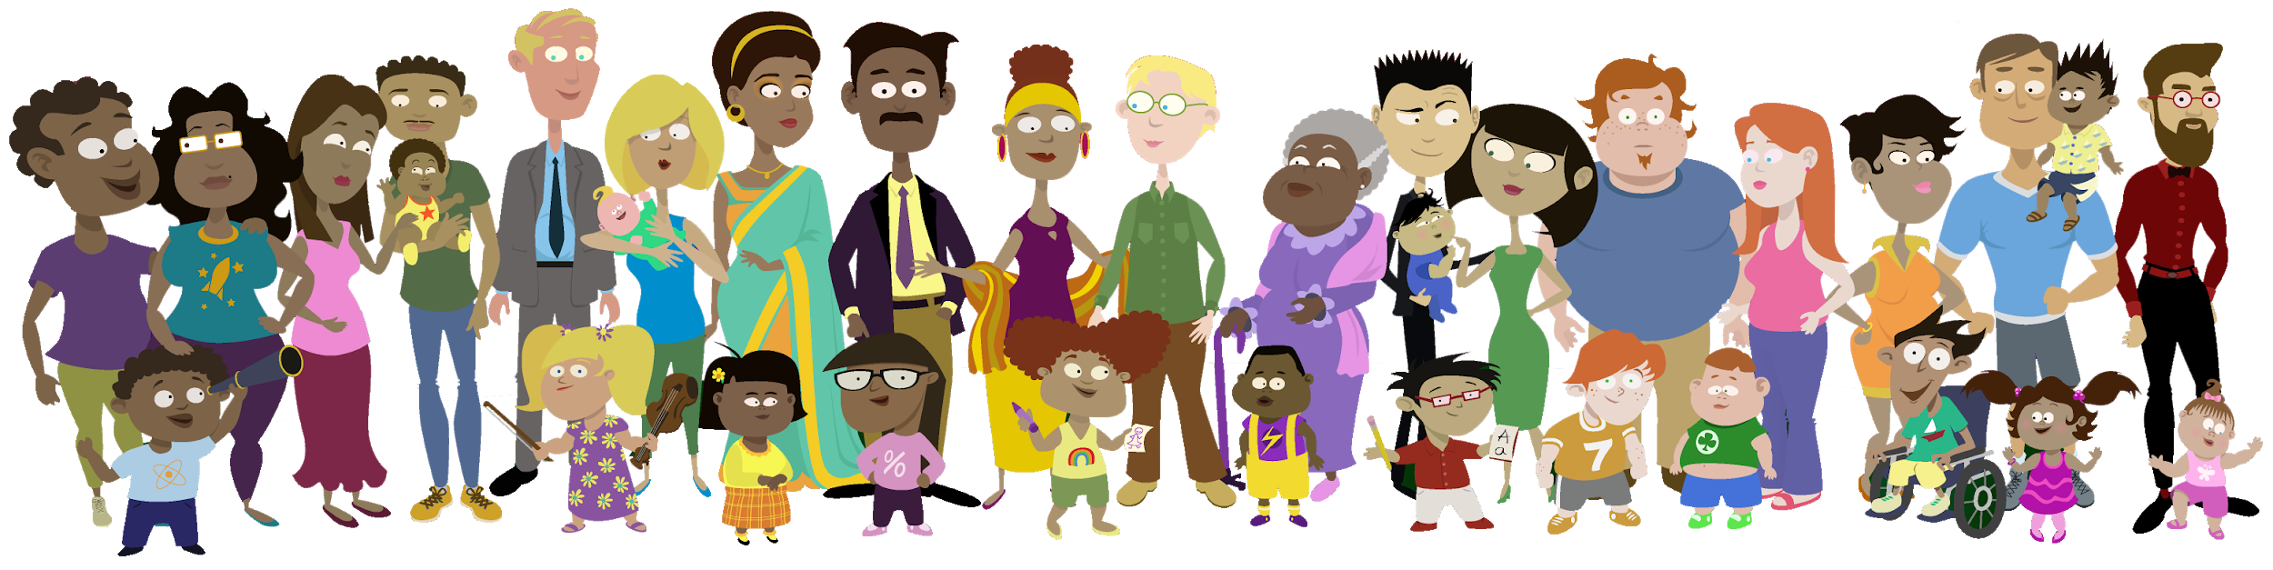

Dear Families,

In this bag, you will find an activity booklet full of play-based activities created by the Children’s Learning Institute (CLI) for you to do together with your child at home. Most materials you need for these activities are included in this bag as well. You can choose to start with the activity that looks the most fun to you and your child.

Research has shown that young children learn best while playing. Play allows children to explore with their senses and develop important skills like movement and coordination, memory, vocabulary, decision-making, and understanding and expressing emotions.

This leads to healthy brain development. As children grow older, play allows them to use creativity and imagination. When you play with your child, it also helps them feel secure and more attached to you. Playing together lets them know they are safe and loved and that their ideas are important to you.

These activities are meant to be fun for your whole family! If you are interested in finding more of these activities to do with your child or other children in your home, please visit the CIRCLE Activity Collection: Family at cliengagefamily.org. There are many free, research-based activities on this website for children ages 0–11 to support their developmental skills across all learning areas!

Please feel free to reach out if you have any questions, need any help in getting started, or have feedback about your experience using these materials at home with your child. Thank you!

